The Greater Peace Baptist Emergency Prepardness Minisrtry
Team Members: Deacon Michael Forte, Deacon Keith Mitchell, Latasha Bradley, James Bradley, Kelfe Parker, Roz Fletcher, Trina Cummings.
Objective: The purpose of the Emergency Preparedness Ministry is to serve God and our fellow parishioners by seeking to prepare, develop, implement and monitor an effective emergency response plan for our church and community. To be ready to respond to inclement weather by the purchasing, gathering, receiving and distributing needed supplies.
Goals/Roles:
*Monitor closely inclement weather and advise the pastor of possible needs to close or reschedule services and programs.
*Work closely with Mt Calvary Association, 4th District of GMBC, Georgia Missionary Baptist Convention and National Baptist Convention Emergency Preparedness Teams.
*Handle the gathering, receiving, and distribution of materials needed due to a natural disaster.
Operational Motif: P.R.A.Y ( Prepare Respond Assist Yield)
Under the direction of Pastor Corey J. Neal, Greater Peace Baptist Church, the Greater Peace Baptist Emergency Preparedness Ministry has been created to respond to natural diasters that may effect the Chattoochee Valley Area and surounding counties. The Atlantic hurricane season lasts from June through November and, although most of the time all that happens is some heavy bouts of rain, but some major hurricanes have hit the region in recent years. The best type of hurricane is the one that doesn't make landfall, but there are times when people won't be so lucky. That is why it's essential always to be prepared. The church may be called to respond to relief efforts this year. We thank GOD for this opportunity that as a minstry we can go into a status-proactive mode. To fulfill our oblagation we must be able to respond immediately with items of necessity that will provide immediate relief. No matter if you're living in a hurricane-prone area or just there on vacation, knowing what to do before, during, and after a severe tropical storm can go a long way to keeping everyone safe.That said it is essential to adopt an operational motif that is spirtually connecting and descriptively mission defining: Prepare, Respond, Assist, and Yield (P.R.A.Y).
Pr epare
Recent natural catastrophes, from hurricanes to western wildfires, are a fresh reminder that disaster can strike at any time. All proper preparations should be done before the hurricane hits to ensure that you aren't left without certain necessities. When a major hurricane is headed toward an area, people tend to panic. Stores run out of essential staples like water, batteries, and flashlights very quickly. We live in a hurricane-prone area, therefore we should always be stocked with the staples, so we never have to worry about the panicking crowds. We should also be prepared even if you're traveling to an area that may be affected by these severe storms. No area of the country is immune, when you factor in the while the circumstances may differ, there’s one tip that every person needs to take from all these situations: how to pack a “go bag.”
The Emergency Preparedness is requesting that memebers have the follwing items avaiable:
Waterproof book- bag
Rain-boots
Poncho
Non-perishable Can goods
Flash Lights
Batteries
Latex Gloves
Sterile Bandages
Band-Aids
Hand Sanitizers
Towelettes
Antibiotic Ointment
Candles
Matches in & Waterproof Container
Can Openers
Toilet Paper
Feminine Products
Garbage Bags
Bleach
Disinfectants
Toiletries
Blankets
Paper Cups
Paper Plates
Plastic Utensils

The image below is an animated caption of an evcuation bag.
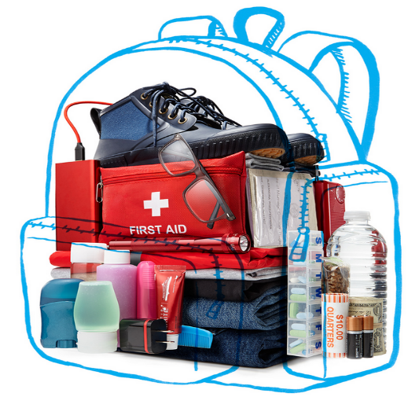

A video has been created to provide a visual for church members. The video assists with providing an actual image of some items that will be needed if you have to evcaulate your residence.
Make a plan: When an emergency strikes, you and your family must have a plan in case you get separated. Agree on a common meeting place that is easy to find and a method of contact. Additionally, you'll want to know the safest place to hunker down during the storm, so stake out a location away from any windows when you arrive where you can take shelter. A go bag is a packed case that you grab on your way out the door, and that will help keep you safe and comfortable in the coming hours and days. Stopping to hunt for your medications or other important needs can cost you critical seconds in an evacuation. Pack a separate go bag for yourself and every member of your household, and keep them stored in the same location.
1. Fill your car with gas.
3. Basic Electronics Pack an extra phone charger in case you’re fortunate enough to have electricity, and a portable battery pack in case you’re not. Also stash a long-lasting LED flashlight. Pack a small hand-cranked or battery-operated AM/FM radio (with extra batteries).
2. Personal needs. While getting ready for a typical day, list every toiletry you use, then buy a travel-size version of each. Pack backup eyeglasses, as well as a first-aid kit, baby wipes and a multipurpose tool with a knife and can opener.
3. Clothing. Pack a few days’ worth. Include layers you can add or remove, plus lightweight rain gear and waterproof boots.
4. Your meds. Pack about three days’ worth of each of your prescriptions, which should last until you can get to a pharmacy that’s open. If you need larger items, such as an oxygen tank, make sure you have a portable version.
5. The perfect bag. Think small and portable. A backpack is ideal, but a lightweight suitcase with wheels will also do. Just remember, you may literally be running with it.
6. Paperwork. Fill a zip-top waterproof bag with photocopies of your birth certificate; driver’s license; Social Security and Medicare cards; power of attorney and will; any marriage, adoption or naturalization certificates; proof of address; insurance, medical and immunization records; and information about your credit and ATM cards.
7. Food and drink. Bottled water is essential. Granola or energy bars are great because they are small and filling, and they come in a variety of flavors.
8. Cash. In addition to enough money for a few days, include small bills and a roll of quarters. If you need to buy something out of a vending machine, you don’t want to start asking equally desperate strangers for change.

Respond
Evacuating Before or After a Storm
If you live near the coast or in a flood-prone area, you may be asked to evacuate. Your "plan" should include researching your evacuation route and making arrangements in advance with family or friends for a safe place to stay.
During a Hurricane stay away from low-lying and flood prone areas. Always stay indoors during a hurricane, because strong winds will blow things around. Leave mobile homes and to go to a shelter. If your home isn't on higher ground, go to a shelter. If emergency managers say to evacuate, then do so immediately. Stay inside and keep away from all windows, skylights and glass doors. Go to a safe area, such as an interior room, closet or downstairs bathroom. Never go outside the protection of your home or shelter before there is confirmation that the storm has passed the area.
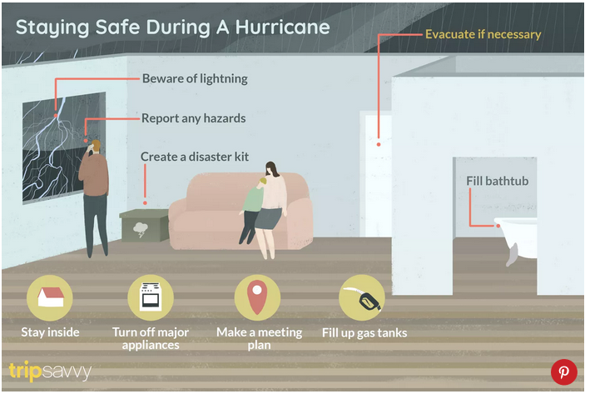

Make sure your windows are protected, and your home is secured. This may mean putting up hurricane shutters, which should be done in the days before a hurricane is coming. This also includes tying down or taking in any outdoor furniture, garbage cans, outdoor decor, or lawn supplies that can blow away during heavy winds.
Area public shelters are for people who have no other place to go. If you must stay in a shelter, listen to news broadcasts for announcements of shelter openings. Shelter volunteers do their best to make you comfortable, but a shelter is not a very comfortable place. Stay with friends or relatives if at all possible.
Those with special medical needs such as oxygen should go to special needs shelters only. Special needs shelters do not provide hands-on medical care, only medical monitoring. Bring a caregiver with you if possible. Only service animals are permitted in public shelters. Shelters that allow pets are limited, so other arrangements should be made for your pets.
*Bring food and snacks. Meals may not be available during the first 24 hours.
*Bring your identification, valuable papers, and medications in their original containers.
*Bring baby supplies if you have a small child.*Bring blankets, sleeping bags, and pillows, which are either not provided or limited in supply at shelters. You may also want to bring cards, games, or books to help pass the hours while you wait for it to be safe to travel.
Assist
The Greater Peace Emergency Preparedness Ministry will discuss and determine the most effective way to help church member’s survivors in the community following a natural disaster. It is recommended that the most effective assistance is with a financial gift to disaster relief organizations that have strong presence in affected communities. We will suggest the creation of a Disaster Relief Fund Account or a financial drive to increase the amount funds that may be needed to assist victims of a natural disaster. of the These organizations have likely already produced response plans for emergency situations such as these. And they depend on our donations to provide immediate relief.
1. More so than donated goods, financial donations can be given quickly, are versatile, and remain helpful beyond the initial response by aiding in long-term recovery work. No matter how much you can give, every dollar goes a long way.
2. Give Blood. If you’re eligible, giving blood is an especially meaningful way to help out in the wake of hurricanes and other natural disasters. In extreme weather conditions, road travel is often hazardous, preventing regular donors from giving and canceling scheduled blood drives. At the same time, however, there’s often increased demand for blood from hospitals.
Unlike other medical supplies, blood and platelets can’t be stockpiled in advance due to having a short shelf life. If you can donate, you can help ensure that there continues to be a sufficient blood supply for those in need. Contact the American Red Cross or local organizations.
3. Donate Goods. While donating items is very generous, do NOT send unsolicited donations to organizations helping with hurricane relief. Sorting through, cleaning and distributing goods can be costly and divert time and resources from more urgent needs.
4. Volunteer Time. While watching disasters like Hurricane Dorian unfold, many of us may feel the need to travel to affected areas and volunteer. Although the impulse is commendable, you may end up going more harm than good. In fact, we highly recommend that you do not self-deploy to disaster-stricken areas.
Before deciding where and how to volunteer your time, it’s important to assess the situation and your skillset. For example, if you aren’t currently trained or certified in disaster relief, your time may be better spent helping with long-term recovery efforts rather than the initial response.
For those who live in affected communities, you may be able to find volunteer opportunities at your local American Red Cross chapter, where you can help serve meals, register clients and more. Or, you may consider reaching out to local organizations.
Yield
More deaths and injuries occur after a hurricane hits than during. This is because people are too anxious to get outside and survey the damage and come into contact with downed power lines or unstable trees. Follow these suggestions for staying safe after a hurricane:
* Remain indoors until an official "all clear" is given.
* Do not touch fallen or low-hanging wires of any kind under any circumstances. Stay away from puddles with wires in or near them. Do not touch trees or other objects in contact with power lines.
* Use phones for emergencies only and call 911 only for life-threatening situations.
*Call police or utility companies immediately to report hazards such as downed power lines, broken gas or water mains, overturned gas tanks, or any other dangerous situation you come across.
*Watch for weakened roads, bridges, tree limbs, porches that could collapse unexpectedly, and never drive through floodwaters of any level.
*After power is restored, check refrigerated food for spoilage, which is the cause of much sickness two days to a week after the storm.
* When reinstalling a cable base, TV, or satellite antenna, check all directions to be sure no power lines are nearby. The same goes for climbing trees to clear debris.
*Do not operate charcoal grills, propane camping stoves, or generators indoors.

